# Name :- Aryan Lokhande

# Roll No: 32

# Class :- TE(IT)

# Practical 4b :- Deploy/Host Your web application on AWS VPC or AWS Elastic Beanstalk

Here i am using Render website to Deploy my web application.

**index.html**

<!DOCTYPE html>

<html lang="en">

<head>

<meta charset="UTF-8" />

<meta name="viewport" content="width=device-width, initial-scale=1.0"/>

<title>My Cool Web Page</title>

<link rel="stylesheet" href="style.css" />

</head>

<body>

<header>

<h1>Welcome to My Web Page </h1>

<p class="tagline">Showcasing Simplicity & Style</p>

</header>

<section class="about">

<h2>About Me</h2>

<p>Hi! I'm a passionate developer who loves building clean and creative websites. This is a simple page styled with pure HTML and CSS.</p>

</section>

<section class="projects">

<h2>Projects</h2>

<ul>

<li>🌐 Portfolio Website </li>

<li>📱 Weather App </li>

<li>🧠 Machine Learning Model </li>

</ul>

</section>

<footer>

<p>© 2025 My Web Page | Built with ❤️ by Me</p>

</footer>

</body>

</html>

**style.css**

/* Reset default styles */

* {

margin: 0;

padding: 0;

box-sizing: border-box;

}

/* Base styling */

body {

font-family: 'Segoe UI', sans-serif;

background: #f0f4f8;

color: #333;

line-height: 1.6;

padding: 20px;

}

/* Header */

header {

text-align: center;

background-color: #4a90e2;

color: white;

padding: 40px 20px;

border-radius: 12px;

box-shadow: 0 4px 10px rgba(0,0,0,0.1);

}

.tagline {

margin-top: 10px;

font-style: italic;

}

/* Sections */

section {

background: white;

margin: 30px auto;

padding: 25px;

max-width: 800px;

border-radius: 12px;

box-shadow: 0 4px 10px rgba(0,0,0,0.05);

}

h2 {

color: #4a90e2;

margin-bottom: 10px;

}

/* Projects list */

.projects ul {

list-style: none;

padding-left: 0;

}

.projects li {

padding: 8px 0;

border-bottom: 1px solid #ddd;

}

/* Footer */

footer {

text-align: center;

margin-top: 50px;

font-size: 0.9em;

color: #666;

}

**Web Application**

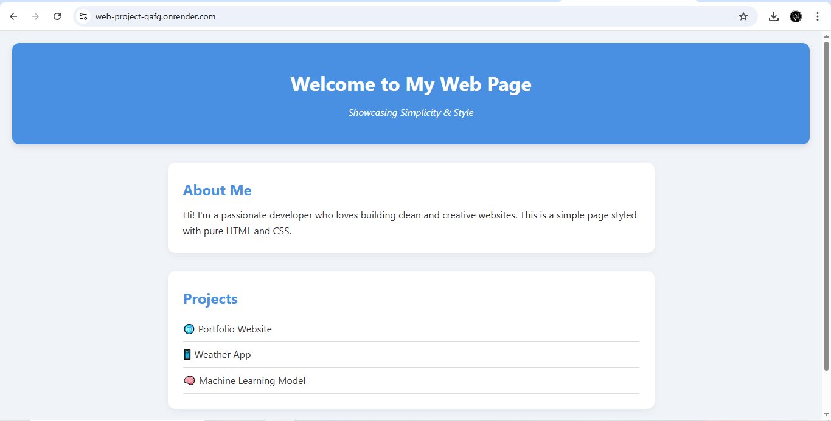

**How to perform**

✅ Step 1: Push Your Code to GitHub

If you haven’t already:

Create a GitHub repo: https://github.com/Web_Project

Upload your project files

Commit & push your code

✅ Step 2: Sign up on Render

Go to https://render.com

Click Sign Up and choose “Sign up with GitHub”

Authorize GitHub access to Render

✅ Step 3: Create a New Web Service

Click “New +” > Static Site

Choose your repo from the GitHub list

Fill in:

Name: Web_Project

Build Command: Leave blank

Branch: main

Root Directory: Leave blank unless your files are in a folder

Environment: Choose “Free”

Publish Directory: "." if your index.html is in root folder

✅ Step 4: Set Environment Variables (if needed)

✅ Step 5: Deploy!

Click deploy static site

Render will build and deploy your app

After a minute or two, your app will be live at:

arduino-

https://web-project-qafg.onrender.com

🔁 To update your app:

Just push changes to your GitHub repo — Render auto redeploys!

**Output :-**

